CSA0604 – DESIGN AND ANALYSIS OF ALGORITHM
LAB PROGRAMS
SESSION 4
NAME: ABZAM.A
REG NO : 192573029

3. Large Groups in a String
Code
#include <stdio.h>
#include <string.h>
void largeGroups(char s[]) {
int n = strlen(s);
int start = 0;
int first = 1;
printf("Input: s = \"%s\"\nOutput: [", s);
for (int i = 1; i <= n; i++) {
if (i == n || s[i] != s[start]) {
if (i - start >= 3) {
if (!first)
printf(",");
printf("[%d,%d]", start, i - 1);
first = 0;
}
start = i;
}
}
printf("]\n\n");
}
int main() {
largeGroups("abbxxxxzzy");
largeGroups("abc");
return 0;
}

Outputs
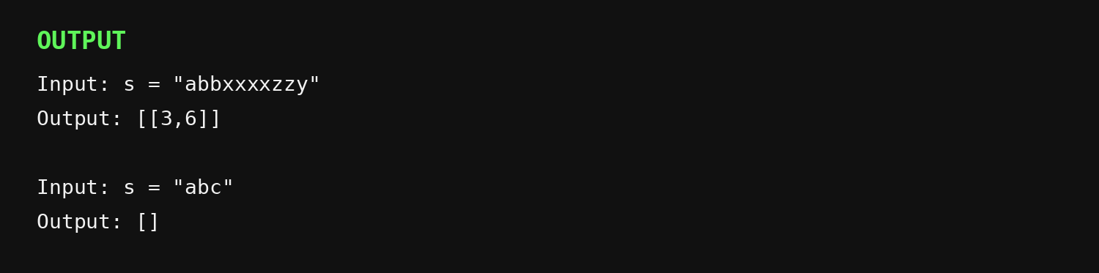

4. Game of Life
Code
#include <stdio.h>
void gameOfLife(int m, int n, int board[m][n]) {
int directions[8][2] = {
{-1, -1}, {-1, 0}, {-1, 1},
{0, -1}, {0, 1},
{1, -1}, {1, 0}, {1, 1}
};
for (int i = 0; i < m; i++) {
for (int j = 0; j < n; j++) {
int liveNeighbors = 0;
for (int d = 0; d < 8; d++) {
int r = i + directions[d][0];
int c = j + directions[d][1];
if (r >= 0 && r < m && c >= 0 && c < n)
liveNeighbors += board[r][c] & 1;
}
if ((board[i][j] & 1) == 1) {
if (liveNeighbors == 2 || liveNeighbors == 3)
board[i][j] |= 2;
} else if (liveNeighbors == 3) {
board[i][j] |= 2;
}
}
}
for (int i = 0; i < m; i++)
for (int j = 0; j < n; j++)
board[i][j] >>= 1;
}
void printBoard(int m, int n, int board[m][n]) {
printf("Output: [");
for (int i = 0; i < m; i++) {
if (i > 0) printf(",");
printf("[");
for (int j = 0; j < n; j++) {
if (j > 0) printf(",");
printf("%d", board[i][j]);
}
printf("]");
}
printf("]\n\n");
}
int main() {
int board1[4][3] = {
{0, 1, 0},
{0, 0, 1},
{1, 1, 1},
{0, 0, 0}
};
printf("Example 1\nInput: board = [[0,1,0],[0,0,1],[1,1,1],[0,0,0]]\n");
gameOfLife(4, 3, board1);
printBoard(4, 3, board1);
int board2[2][2] = {
{1, 1},
{1, 0}
};
printf("Example 2\nInput: board = [[1,1],[1,0]]\n");
gameOfLife(2, 2, board2);
printBoard(2, 2, board2);
return 0;
}

Outputs
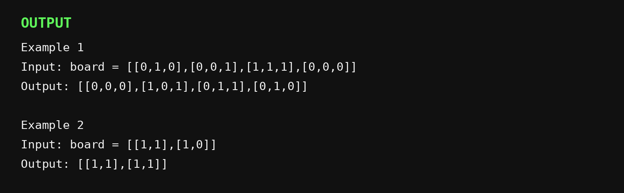

5. Champagne Tower
Code
#include <stdio.h>
double champagneTower(int poured, int query_row, int query_glass) {
double glasses[101][101] = {{0}};
glasses[0][0] = poured;
for (int row = 0; row < query_row; row++) {
for (int col = 0; col <= row; col++) {
if (glasses[row][col] > 1.0) {
double excess = (glasses[row][col] - 1.0) / 2.0;
glasses[row + 1][col] += excess;
glasses[row + 1][col + 1] += excess;
glasses[row][col] = 1.0;
}
}
}
if (glasses[query_row][query_glass] > 1.0)
return 1.0;
return glasses[query_row][query_glass];
}
int main() {
int poured = 1, query_row = 1, query_glass = 1;
printf("Example 1\nInput: poured = %d, query_row = %d, query_glass = %d\n", poured, query_row, query_glass);
printf("Output: %.5f\n\n", champagneTower(poured, query_row, query_glass));
poured = 2;
query_row = 1;
query_glass = 1;
printf("Example 2\nInput: poured = %d, query_row = %d, query_glass = %d\n", poured, query_row, query_glass);
printf("Output: %.5f\n", champagneTower(poured, query_row, query_glass));
return 0;
}

Outputs
